**INTRODUCTION TO JIRA**  
  
  
**1. CREATING PROJECT**  
  
  
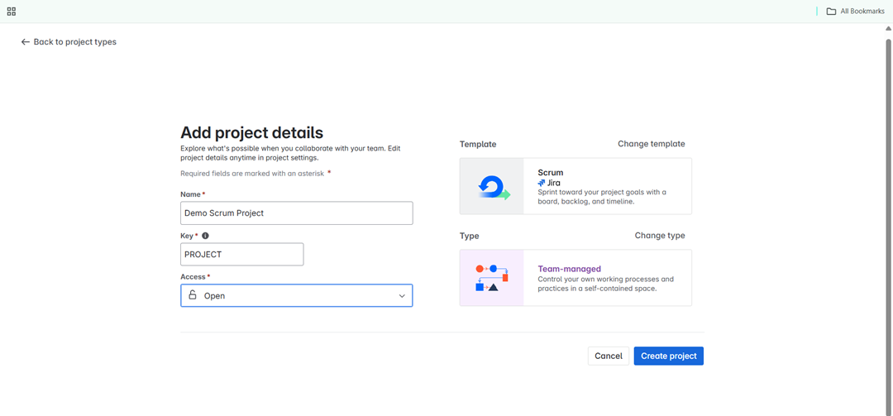

**2. CREATING PROJECT TEMPLATE - SCRUM**

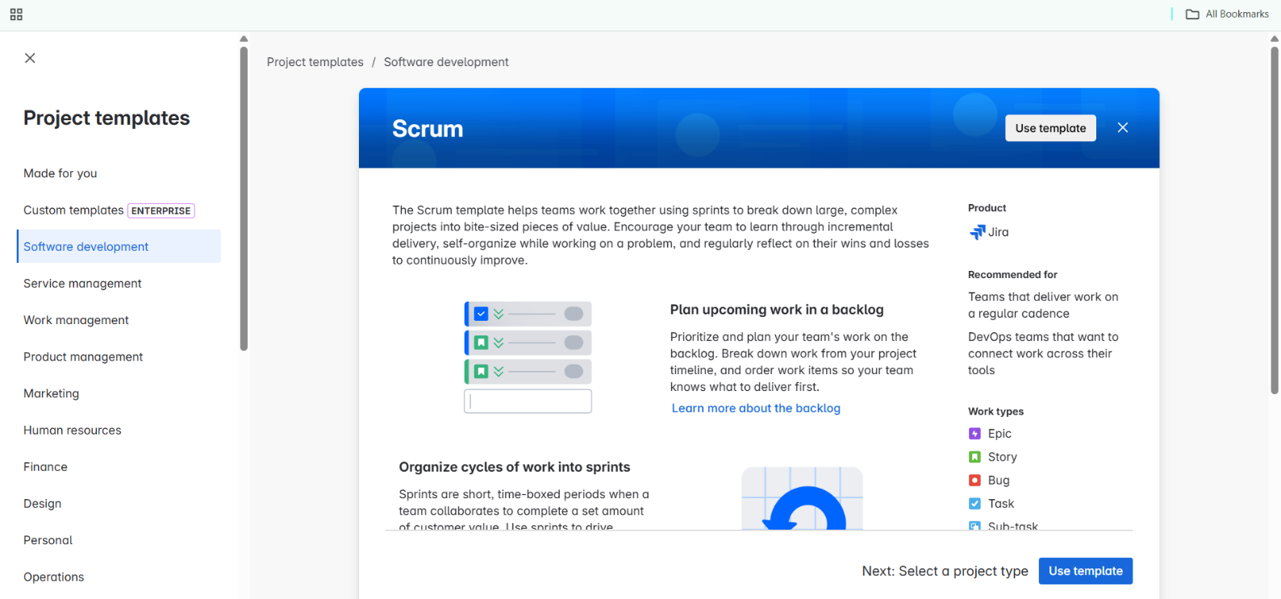

**3. WORKFLOW FOR PROJECT**

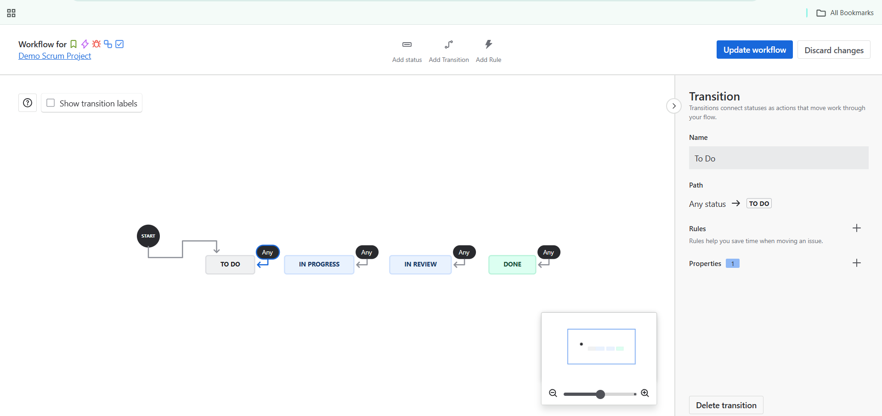

**4. SETTING UP THE WORK FLOW**

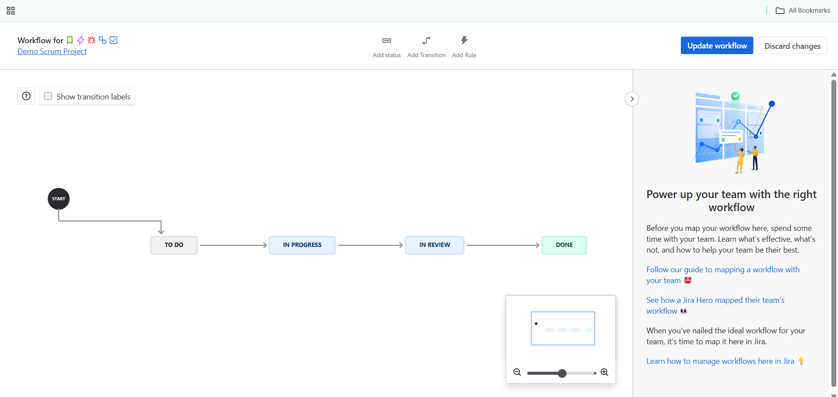

**5. ADDING TASKS**

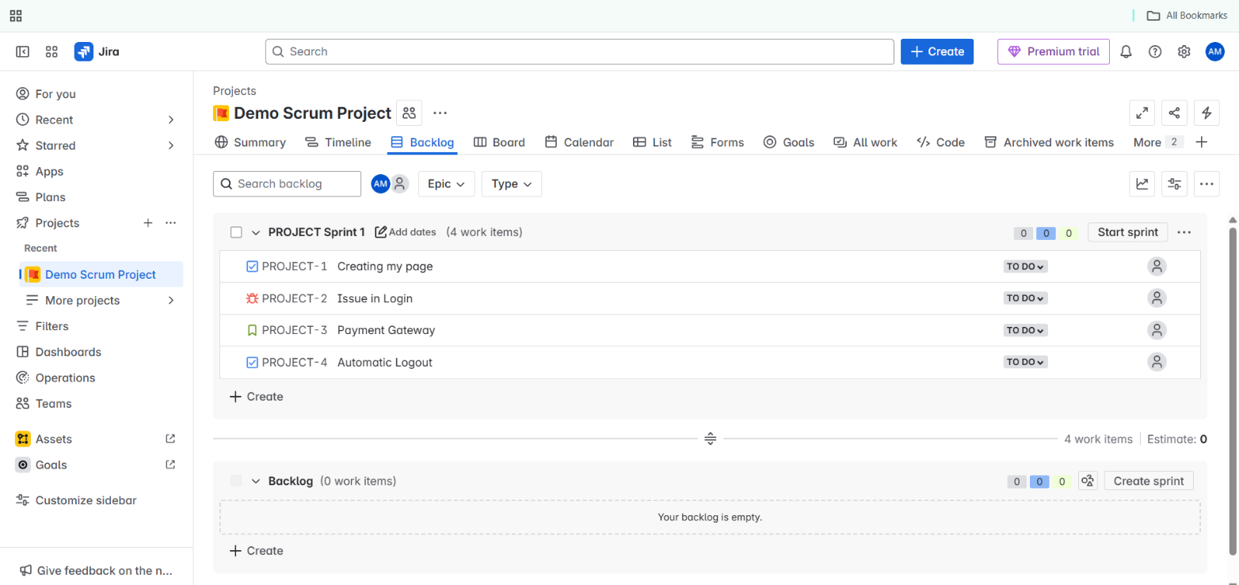

**6. STARTING SPRINT**

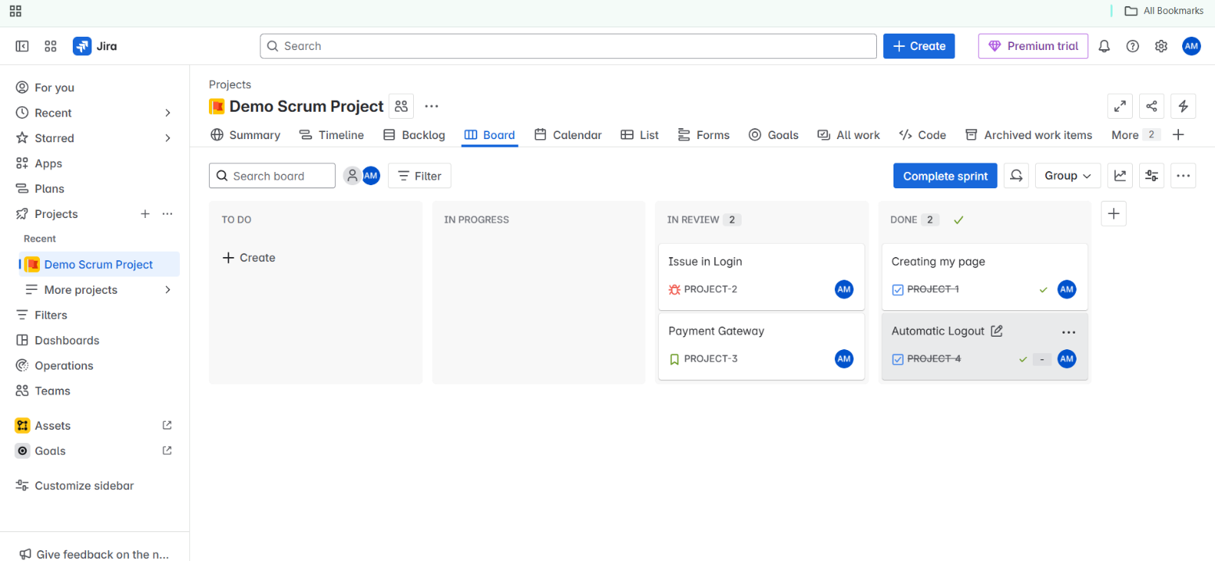

**7. ACTIVITIES IN JIRA**

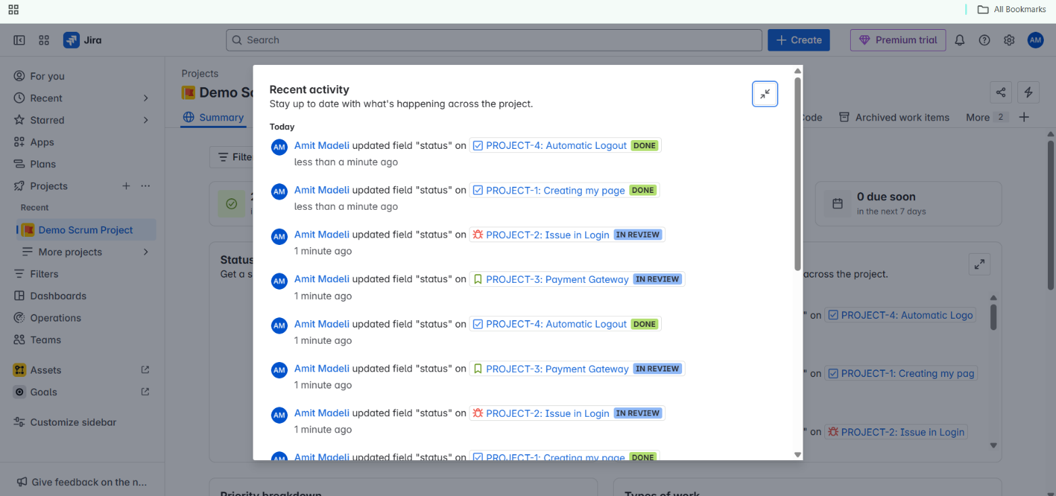

**8. SUMMARY REPORT**

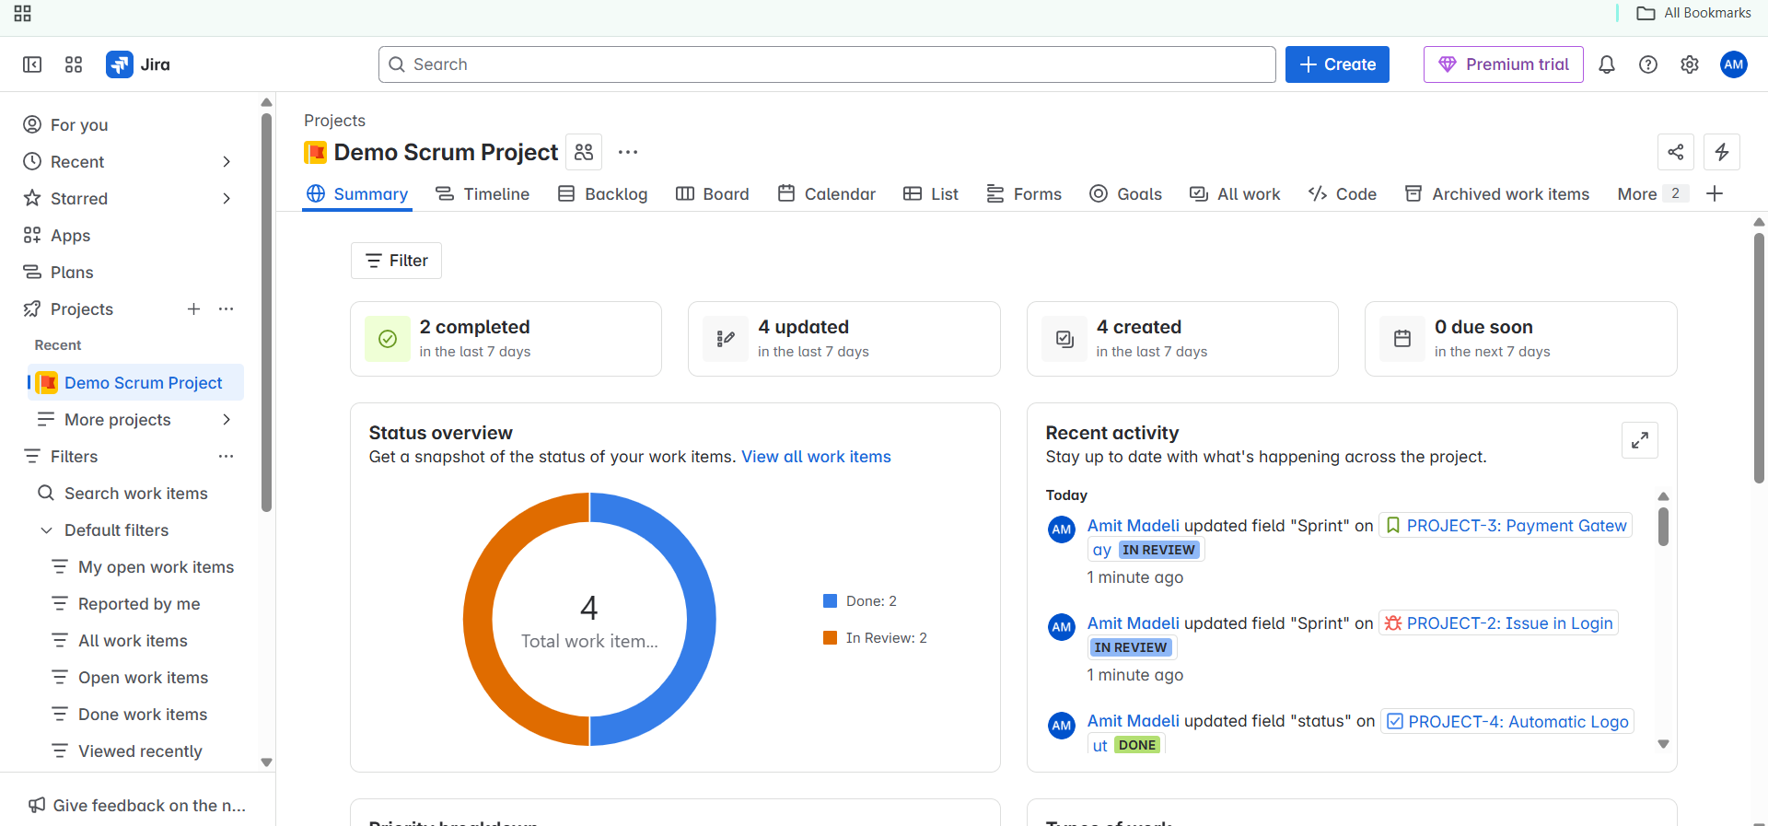

**9. PROJECT COMPLETED**  
  
  
